Git link: https://github.com/ManaTariq/FM-assignment

Mana Tariq

00000130293

BESE 6B

Assignment 3 on Uppaal

**Q1.** [5 marks] Take the example of Jobshop from Uppaal demos. (i) Add more jobbers and accommodate the changes:

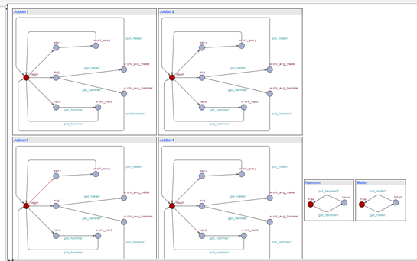

Code:

// Place template instantiations here.

//ManaTariq

//Bese6B

Jobber1 = Jobber();

Jobber2 = Jobber();

Jobber3 = Jobber();

Jobber4 = Jobber();

// List one or more processes to be composed into a system.

system Jobber1, Jobber2,Jobber3,Jobber4, Hammer, Mallet;

(ii) Add and check at least two properties in Uppaal verifier

Property 1 code:

//ManaTariq

//Bese6B

A[] Hammer.taken == (Jobber1.work_avg_hammer || Jobber2.work_avg_hammer || Jobber3.work_avg_hammer || Jobber4.work_avg_hammer || Jobber1.work_hard || Jobber2.work_hard || Jobber3.work_hard) || Jobber4.work_hard

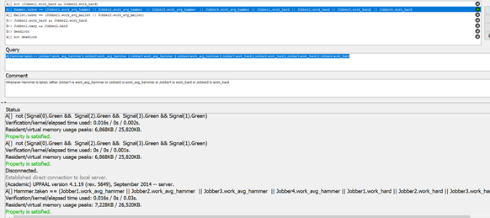

Property2 code:

E<> Jobber2.avg && Jobber3.easy && Jobber4.hard

**Q2.** [5 marks] The New Islamabad International Airport is operational from May

3, 2018. Traffic on Shahrah-e-Kashmir (major road) is 8 times as compared to the traffic on the minor road at the G-11 signal crossing. CDA wants NUST’s software engineers to provide a complete Uppaal diagram of traffic flow diagram with directions and proposed timings for optimal traffic flow. Diagram of all the important objects for the system is mandatory for execution in simulator. In the verifier must check the following three properties:

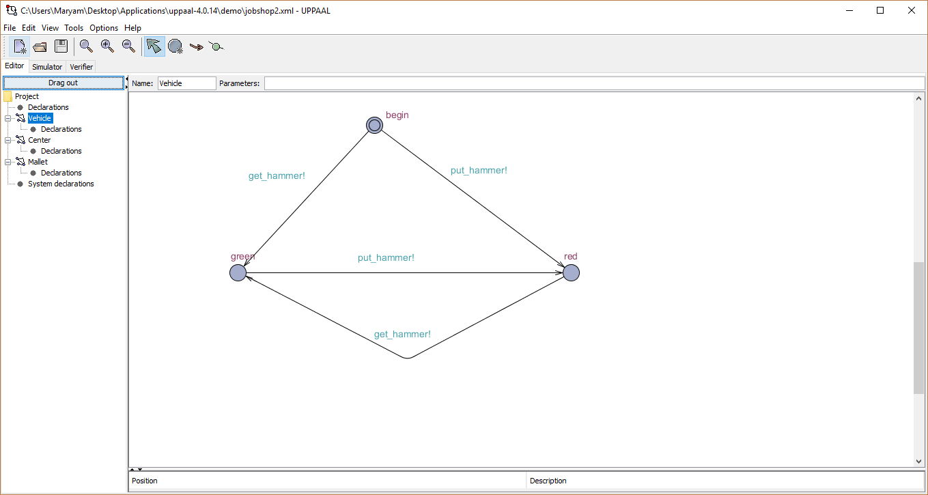

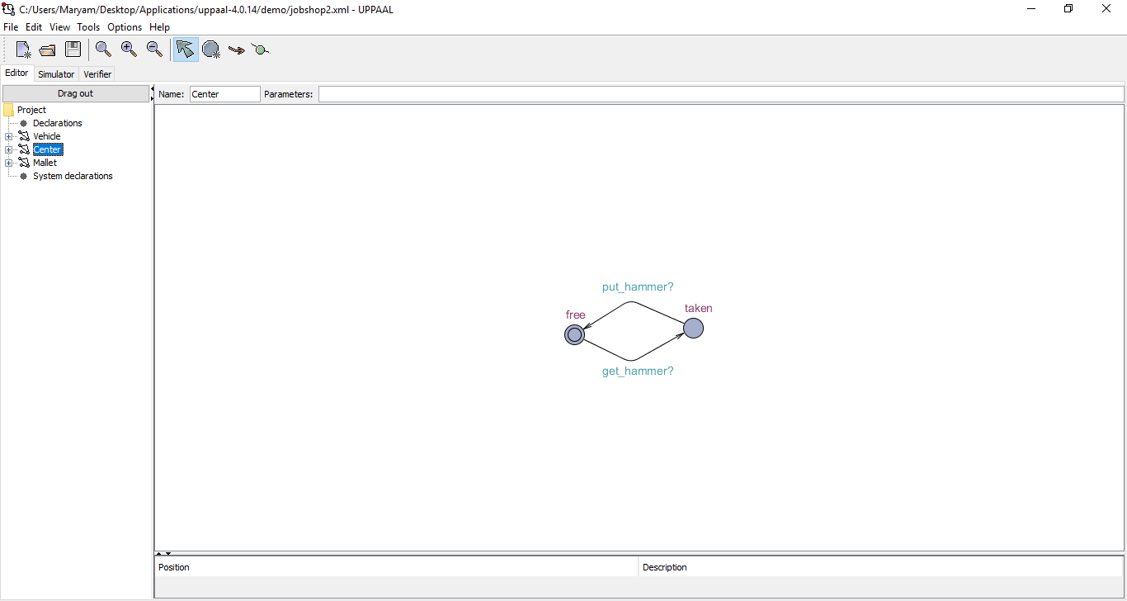

1. Mutex Property

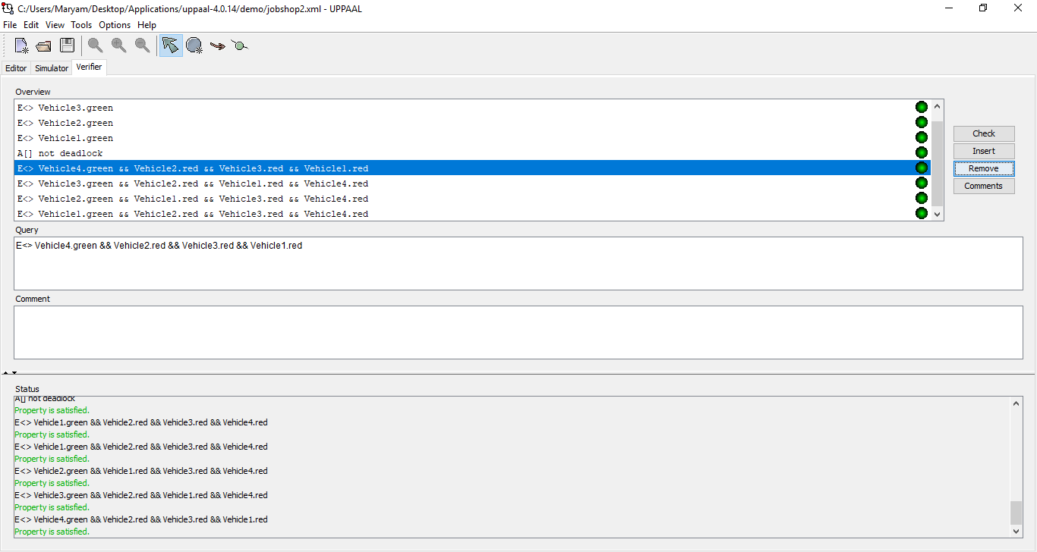

1. Bounded liveness

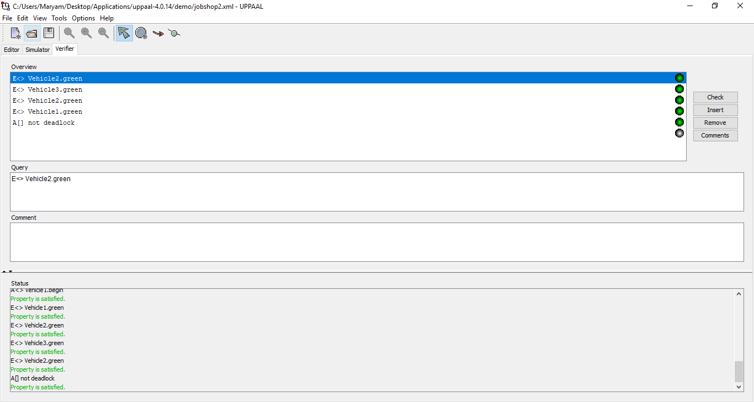

1. Deadlock avoidance

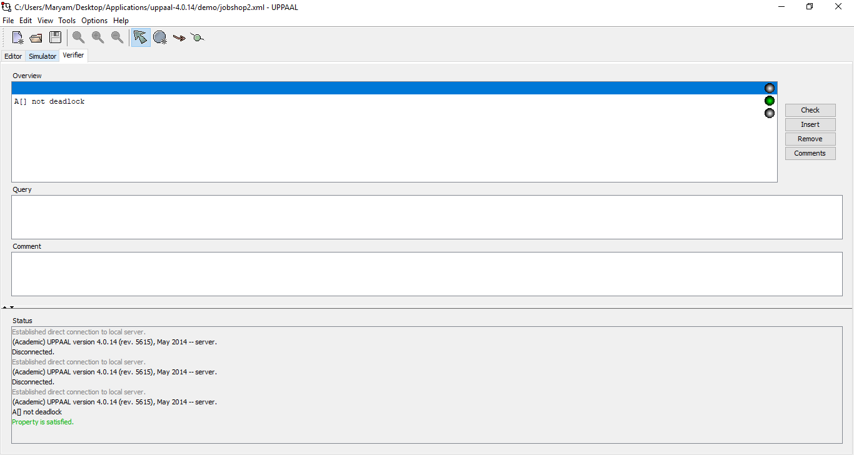

**Facebook Knowledge Sharing: [2 Bonus marks]**: Add 2 screenshots of where you have added:

1. Some information with your comments:

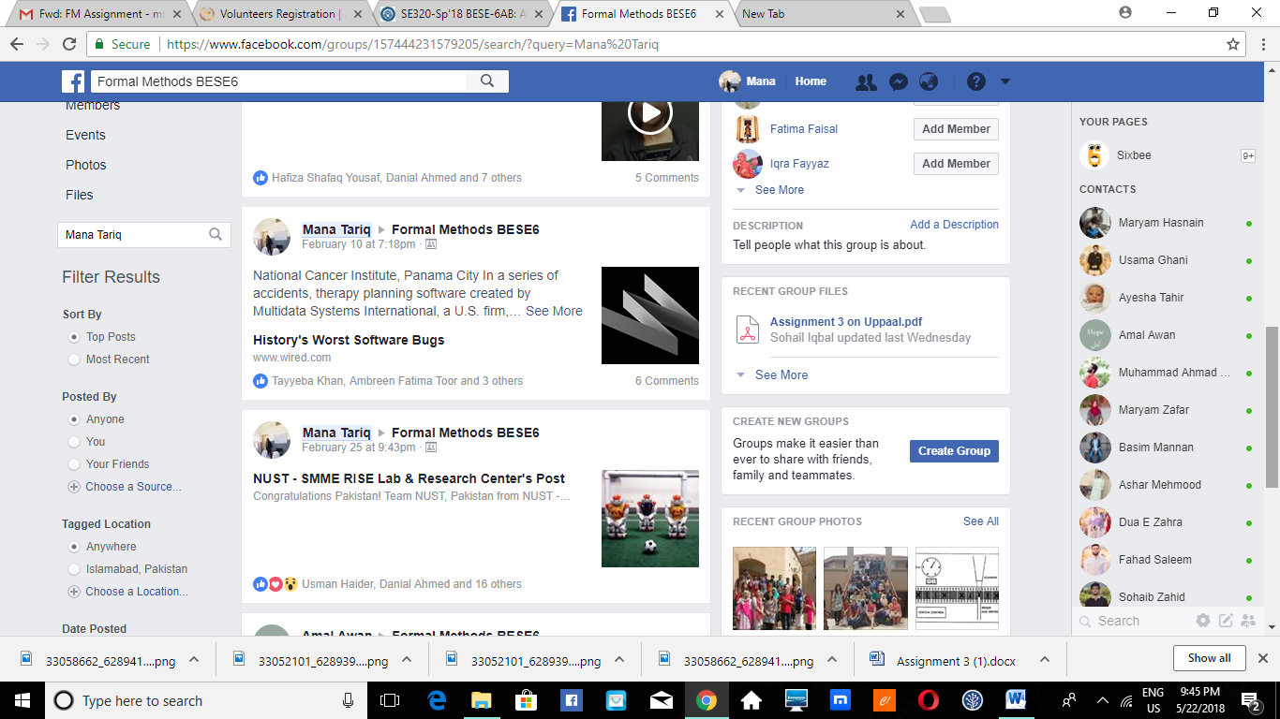

1. Some comments on your anybody else post, prior to 15 May 2018.

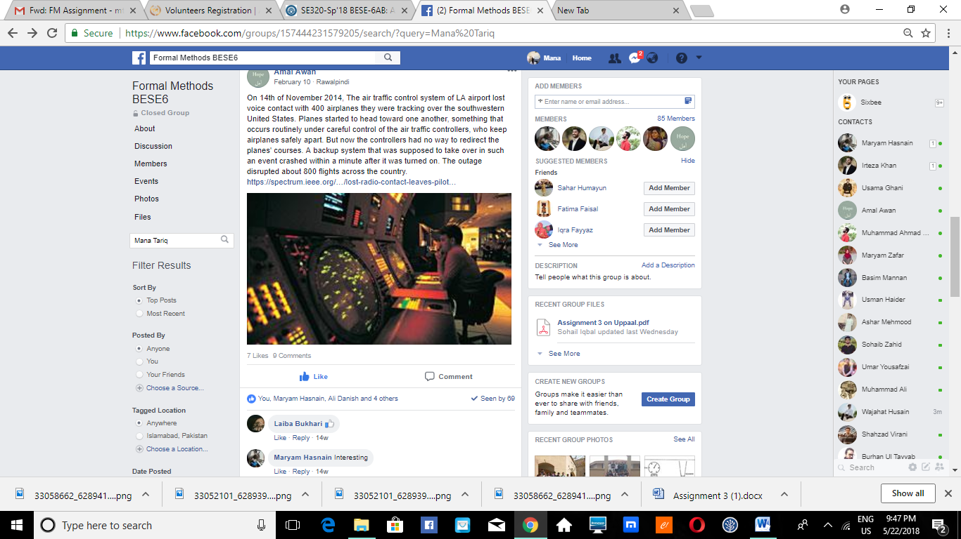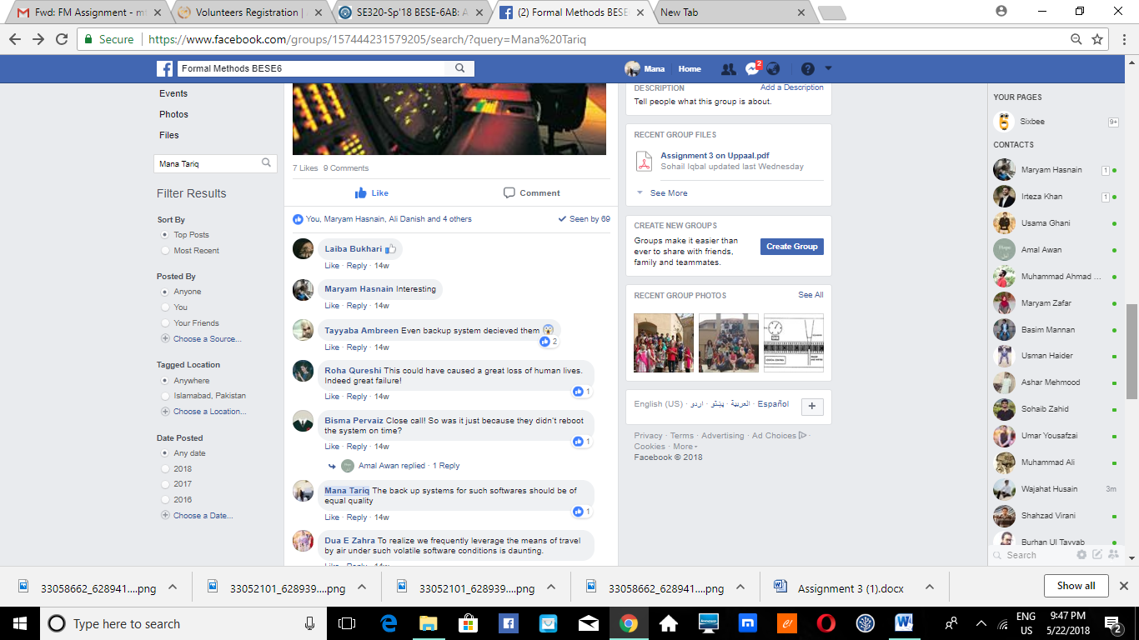

Assignment Deadline: Tuesday, 22 May 2018